This tool called Cmask (Cirrus cloud mask) is used for cirrus cloud detection in Landsat 8 imagery using a time series of data from the Cirrus Band (1.36 – 1.39 µm). This document introduces how to use the Cmask tool (Matlab code).

*Italic* means Matlab function or command.

Red means very important information.

The example data is availableat[**https://drive.google.com/drive/folders/1LTPuRc4-qVOHSfGguD6g4wBeJ30oPqXv?usp=sharing**](https://drive.google.com/drive/folders/1LTPuRc4-qVOHSfGguD6g4wBeJ30oPqXv?usp=sharing)**.**

**Contents**

Section 1: Data (Landsat TOA and Merra2 water vapor) Downloading

Section 2: Generation of Cmask Inputs (Matlab function: *autoPrepareCmaskInputESPA*)

Section 3: Generation of Background Layer (Matlab function: *autoCmaskBackground*)

Section 4: Generation of Cirrus Mask (Matlab function: *autoCmaskDetectCirrus*)

If any questions, please contact Shi Qiu ([shi.qiu@uconn.edu](mailto:shi.qiu@uconn.edu)) and Zhe Zhu ([zhe@uconn.edu](mailto:zhe@uconn.edu)).

Last updated on 9 August 2020

**1. Data Downloading**

*1.1. Landsat 8 TOA product*

The Cmask tool requires the time series of Landsat 8 Cirrus Band TOA reflectance (Band 9; 1.36 – 1.39 µm). To download the TOA data is similar as what we download other Landsat product/bands, but we need to ensure all the images spatially aligned (same spatial resolution and same extent). Here, we will show two ways to download them. If users are focusing on U.S., we recommend downloading Landsat Analysis Ready Data (ARD). If other regions of interest, ESPA Landsat Level-2 product is recommended.

1.1.1. Landsat Analysis Ready Data (ARD) (only for U.S.)

Landsat ARD are provided with non-overlapping tiles of 5000 × 5000 30-m pixels (Horizontal/Vertical tile). Until now they are available only for U.S. and they can be downloaded from USGS Earth Explorer ([https://earthexplorer.usgs.gov](https://earthexplorer.usgs.gov/)).

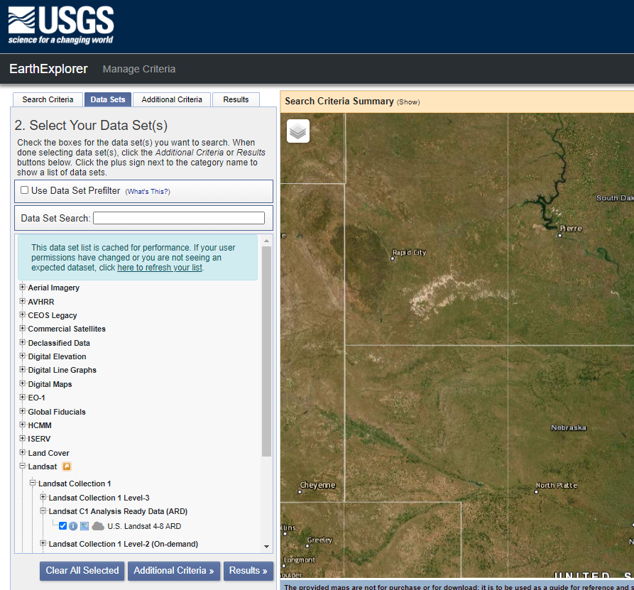

Figure 1. USGS Earth Explorer. Landsat C1 Analysis Ready Data (ARD) is selected.

1.1.2. ESPA Landsat Level-2 product

We recommend downloading the Landsat 8 Level-2 TOA product via USGS EROS Science Processing Architecture (ESPA) On Demand Interface (<https://espa.cr.usgs.gov/index>; Last access on August 7, 2020). The ESPA can provide the time series data **with a same extent (customized option)**. The downloaded data will include the Cirrus Band TOA reflectance file (Figure 2).

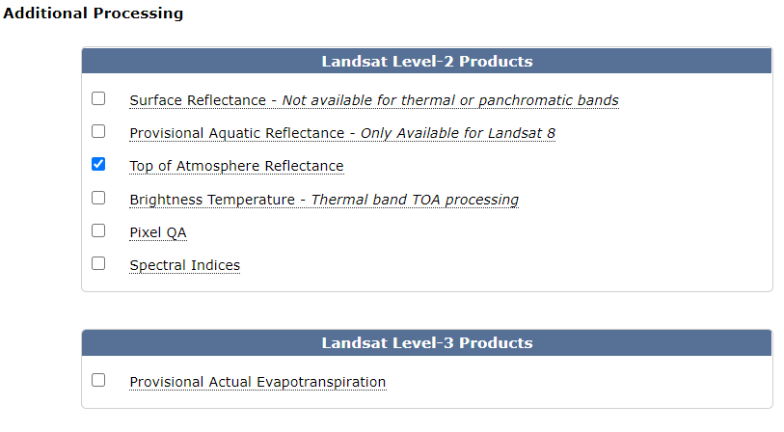

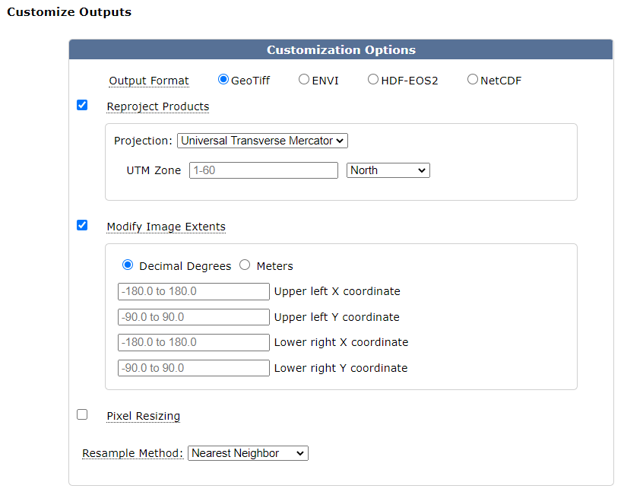

Figure 2. ESPA Interface to download Landsat 8 TOA product. The Top of Atmosphere (TOA) Reflectance should be selected. Customizing all images into a same projection and same extent is commended; or a local preprocessing will be necessary (See Section 2 for details). The Landsat scene ID list is required, which can be obtained from USGS Earth Explorer (tips: metadata).

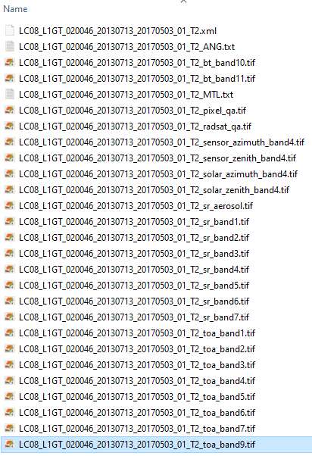

Figure 3. An example of downloaded Landsat 8 TOA data. The band file named by end of ‘toa_band9.tif’ (the last selected one) will be used in Cmask.

***1.2. Integrated Water Vapor***

Integrated Water Vapor (IWV) is provided by the second Modern-Era Retrospective analysis for Research and Applications (MERRA-2). The MERRA-2 water vapor data can be found via the link <https://disc.gsfc.nasa.gov/datasets/M2I1NXINT_5.12.4/summary> (Last access on August 7, 2020) (Figure 3), or Data Collection Search (<https://disc.gsfc.nasa.gov/datasets>; Last access on August 7, 2020) (Figure 4). We recommend using the ‘Subset/ Get Data’ (Figure 5) to further fine the data region and date range, which can cover the Landsat data.

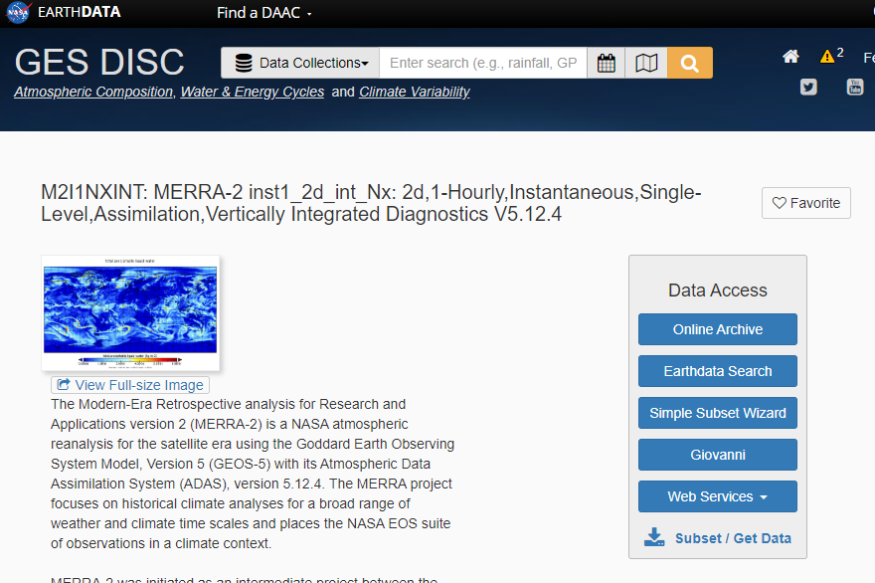

Figure 3. Website of MERRA-2 water vapor data. The ‘Subset/ Get Data’ is recommended to further fine the data region same (same location but larger region) as the Landsat data. Please refer the website to learn how to define the region.

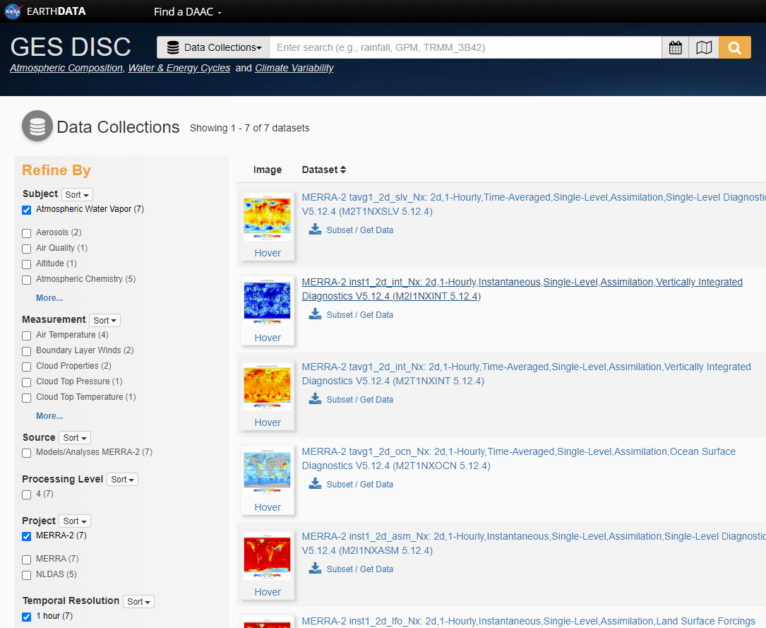

Figure 4. GES DISC to download MERRA-2 water vapor data. The data collection is refined by ‘Atmospheric Water Vapor’, ‘MERRA-2’, and ‘1 hour’, to find the data named by “MERRA-2 inst1_2d_int_Nx: 2d xxx” (the second and blue dataset) for downloading. The ‘Subset/ Get Data’ is recommended to further fine the data region same (same location but larger region) as the Landsat data. Please refer the website to learn how to define the region.

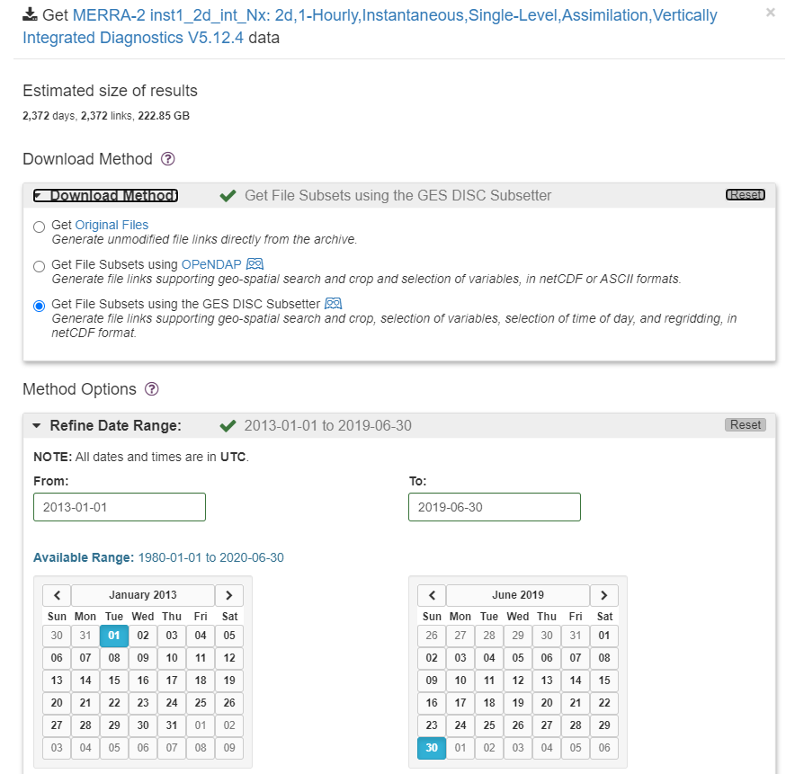

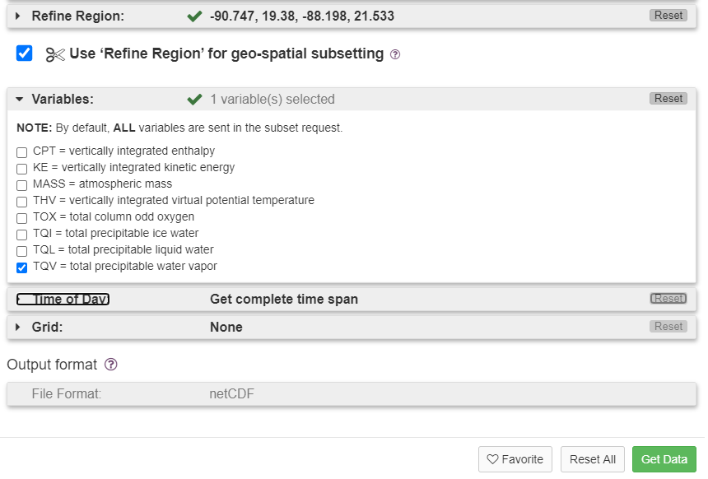

Figure 5. An example of sets in ‘Subset/ Get Data’.

**2. Generation of Cmask Inputs**

The first process is to run ***autoPrepareCmaskInputESPA*** for stacking the Landsat data and water vapor data together, which will be input into Cmask function.

In Matlab Command Window, run *autoPrepareCmaskInputESPA* as the command below, with the Landsat path, the water vapor path, and the output path of the stacked data.

*autoPrepareCmaskInputESPA('DirL', 'C:\Users\qsly0\Desktop\Example_Data_Cmask\espa-xxx-08212018-150747-713', 'DirWV','C:\Users\qsly0\Desktop\Example_Data_Cmask\MERRA2_HourlyWaterVapor', 'DirOut', 'C:\Users\qsly0\Desktop\Example_Data_Cmask\CmaskInput' )*

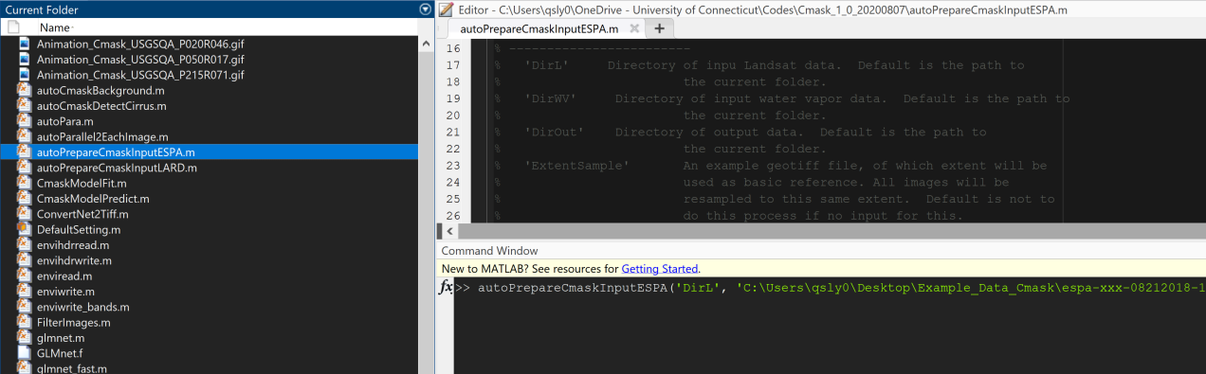

Command Window

The below figure illustrates the output of data preparation:

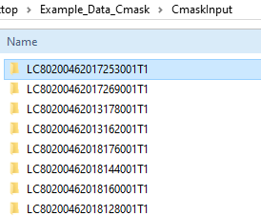 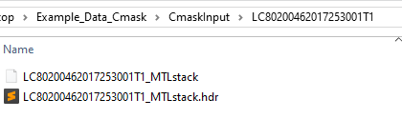

Note: If there is no water vapor data acquired from the same data with Landsat, the following error message will tell us which MERRA2 data needs to be re-downloaded, and then ensure the redownloaded MEERA2 water vapor data is in the same folder as other MEERA2 data.

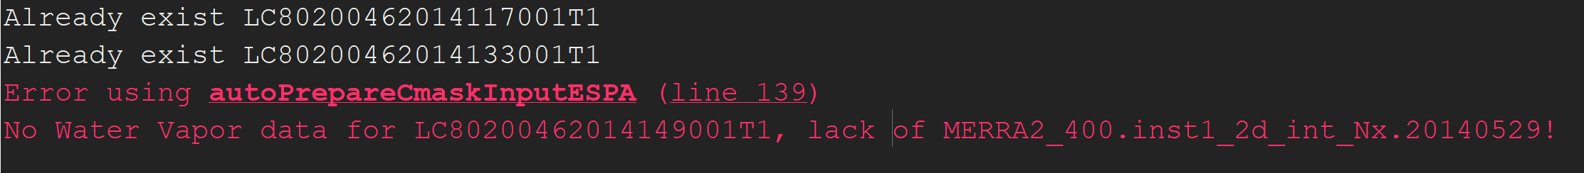

If Landsat ARD, please use *autoPrepareCmaskInputLARD* togeneration Cmask inputs.

**3. Generation of Background Layer**

The second process is to run ***autoCmaskBackground*** for generating time series coefficients, which will be stored in a .hdr file named by ‘LC8 xxx_BG.hdr’ (we could call it ‘background layer’).

In Matlab Command Window, run *autoCmaskBackground* as the command below, with the path of the stacked data and the output path of the background layer.

*autoCmaskBackground('DirIn', 'C:\Users\qsly0\Desktop\Example_Data_Cmask\CmaskInput', 'DirOut', 'C:\Users\qsly0\Desktop\Example_Data_Cmask\CmaskOutput\Background')*

The below figure illustrates the output of background layer:

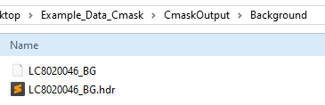

**4.** **Generation of Cirrus Mask**

The last process is to run ***autoCmaskDetectCirrus*** for detecting cirrus clouds by differing the satellite observations with the Cmask model predictions.

In Matlab Command Window, run *autoCmaskDetectCirrus* as the command below, with the path of the stacked data, the path of the background layer, and the output of final cirrus masks.

*autoCmaskDetectCirrus('DirIn', 'C:\Users\qsly0\Desktop\Example_Data_Cmask\CmaskInput','DirBackground', 'C:\Users\qsly0\Desktop\Example_Data_Cmask\CmaskOutput\Background', 'DirOut', 'C:\Users\qsly0\Desktop\Example_Data_Cmask\CmaskOutput\CirrusMask')*

Parameters ‘ThrdNormCirrus’ and ‘ThrdMinCirrus’ can be used to change thresholds to determine cirrus mask.

The below figure illustrates the output of cirrus mask:

